Lab 3: Working with Cascading Style SheetsComplete all these following HTML scripts as explained in my Lab 3 YouTube Video 1. All missing HTML coding are presented in this YouTube video with explanation.

1. Introduction to CSS: All files should be saved under the subfolder htmlclass3

* Style Sheet

The style sheet is a set of declarations describing the layouts and appearance of a document such as Fonts, Text, Color, Backgrounds, Block-level elements, Positioning, Visual Formatting, and Interfaces. There exist three different styles:

In-Line Style Sheet Embedding Style Sheet External Style Sheet

* In-Line Style Sheet

It is possible to associate attributes to a given element such as

<element attribute1=“value1” attribute2=“value2” …>content</element>  
Inconvenient: There is no separation between the HTML content and its style

**Course List5.htm**

1. **<html>**
2. **<head>**
3. **<title>**This is Course List**</title>**
4. **</head>**
6. **<body>**
7. **<address>**
8. 821 Saint-Croix, Montreal, Quebec Canada H4L 3X9
9. **</address>**
10. **<h1** style="color: red;"**>**Vanier College**</h1>**
11. **<h2** style="color: green;"**>**Fall Semester 2022**</h2>**
13. **</body>**
15. **</html>**

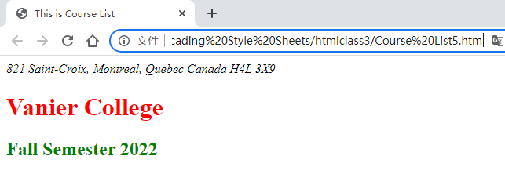

* Embedding a Style Sheet: The power of style sheet is to collect all of the styles used in  
  the document in an embedded style sheet that is placed in the head section of the  
  document. Embedded style sheet are created using the style element.

**courselist1.htm**

1. **<html>**
2. **<head>**
3. **<title>**This is the Course List**</title>**
4. **<style** type="text/css"**>**
5. h1 {color: green}
6. h2, h3 {color: red}
7. **</style>**
8. **</head>**
9. **<body>**
10. **<h1>**Vanier College**</h1>**
11. **<h2>**Fall Semester 2022**</h2>**
12. **<h3>**Course List**</h3>**
13. **<dl>**
14. **<dt>**HTML and **<i>**Internet**</i>** Programming**</dt>**
15. **<dd>**Learn how to Develop Web Site**</dd>**
16. **<dt>**Analysis of The Work Function & Communication**</dt>**
17. **<dd>**Basic of Communication at work place**</dd>**
18. **<dt>**Association of Law Notions to the Professional Practice**</dt>**
19. **<dd>**Key Elements of Law**</dd>**
20. **</dl>**
21. **</body>**
23. **</html>**

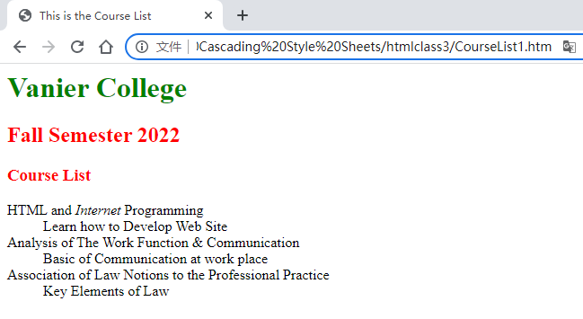

* Using an External Style Sheet:Embedding style sheet is applied only to the current Web Page. You can place the style  
  declarations in an external file (with an extension .css) to be used by the entire Web Site.

**format2.css**

1. /*
2. My First CSS file for Style formatting
3. Author Qingjun Bao
4. */
6. html {**font-family**: Times New Roman, sans-serif;}
8. h1 {**color**: green;}
9. h2, h3 {**color**: red;}
10. address {
11. **color**: blue;
12. **text-align**: right;
13. }

* **Linking a Web Page to an External Style Sheet:**

**courselist2.htm**

1. **<html>**
2. **<head>**
3. **<title>**This is the Course List**</title>**
4. **<link** rel="stylesheet" href="format2.css"**>**
5. **</head>**
7. **<body>**
8. **<address>**
9. 821 Saint-Croix, Montreal, Quebec Canada H4L 3X9 **<b>**Tel: 514.744.7500**</b>**
10. **</address>**
11. **<h1>**Vanier College**</h1>**
12. **<h2>**Fall Semester 2022**</h2>**
13. **<h3>**Course List**</h3>**
14. **<dl>**
15. **<dt>**HTML and **<i>**Internet**</i>** Programming**</dt>**
16. **<dd>**Learn how to Develop Web Site**</dd>**
17. **<dt>**Analysis of The Work Function & Communication**</dt>**
18. **<dd>**Basic of Communication at work place**</dd>**
19. **<dt>**Association of Law Notions to the Professional Practice**</dt>**
20. **<dd>**Key Elements of Law**</dd>**
21. **</dl>**
22. **</body>**
24. **</html>**

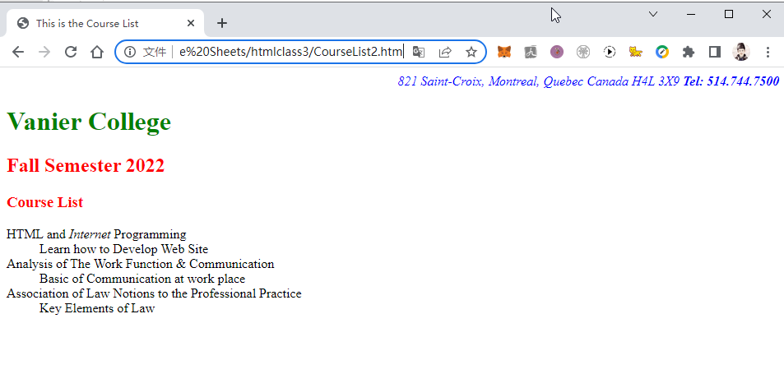

2. Understanding Cascading Order: Style PrecedenceIn case of any conflict in the definition of style, the precedence goes from lowest to highest in the following order:

*▪* Browser’s internal style sheet

*▪* External style sheet

*▪* Embedded style sheet

*▪* Inline styles

* **Style Inheritance:** Style are passed down from the more general levels to the more specific in what is known as **style inheritance**

**courselist3.htm**

1. **<html>**
2. **<head>**
3. **<title>**This is the Course List**</title>**
4. **<style** type="text/css"**>**
5. body {color: blue;}
6. dl {color: red;}
7. **</style>**
8. **</head>**
9. **<body>**
10. **<address>**
11. 821 Saint-Croix, Montreal, Quebec Canada H4L 3X9 **<b>**Tel: 514.744.7500**</b>**
12. **</address>**
13. **<h1>**Vanier College**</h1>**
14. **<h2>**Fall Semester 2022**</h2>**
15. **<h3>**Course List**</h3>**
16. **<dl>**
17. **<dt>**HTML and **<i>**Internet**</i>** Programming**</dt>**
18. **<dd>**Learn how to Develop Web Site**</dd>**
19. **<dt>**Analysis of The Work Function & Communication**</dt>**
20. **<dd>**Basic of Communication at work place**</dd>**
21. **<dt>**Association of Law Notions to the Professional Practice**</dt>**
22. **<dd>**Key Elements of Law**</dd>**
23. **</dl>**
24. **</body>**
25. **</html>**

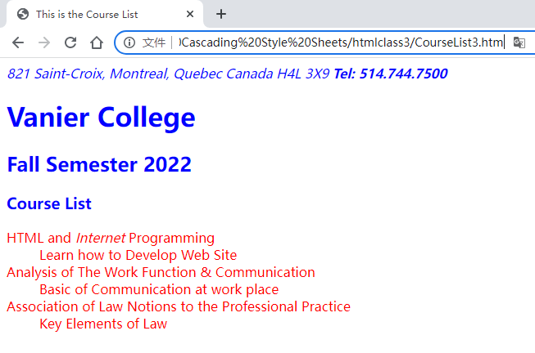

* Applying a Style to a Specific ID: You can apply a style to a specific element marked  
  with an id attribute.

courselist4.htm

1. **<html>**
2. **<head>**
3. **<title>**This is the Course List**</title>**
4. **<style** type="text/css"**>**
5. #ListA {color: blue;}
6. #ListB {color: red;}
7. #ListC {color: black;}
8. **</style>**
9. **</head>**
10. **<body>**
11. **<h2** id="ListA"**>**List A**</h2>**
12. **<p>**Section A**</p>**
13. **<dl>**
14. **<dt>**HTML and **<i>**Internet**</i>** Programming**</dt>**
15. **<dd>**Learn how to Develop Web Site**</dd>**
16. **<dt>**Analysis of The Work Function & Communication**</dt>**
17. **<dd>**Basic of Communication at work place**</dd>**
18. **<dt>**Association of Law Notions to the Professional Practice**</dt>**
19. **<dd>**Key Elements of Law**</dd>**
20. **</dl>**
21. **<h2** id="ListB"**>**List B**</h2>**
22. **<p>**Section B**</p>**
23. **<dl>**
24. **<dt>**HTML and **<i>**Internet**</i>** Programming**</dt>**
25. **<dd>**Learn how to Develop Web Site**</dd>**
26. **<dt>**Analysis of The Work Function & Communication**</dt>**
27. **<dd>**Basic of Communication at work place**</dd>**
28. **<dt>**Association of Law Notions to the Professional Practice**</dt>**
29. **<dd>**Key Elements of Law**</dd>**
30. **</dl>**
31. **<h2** id="ListC"**>**List C**</h2>**
32. **<p>**Section C**</p>**
33. **</body>**
34. **</html>**

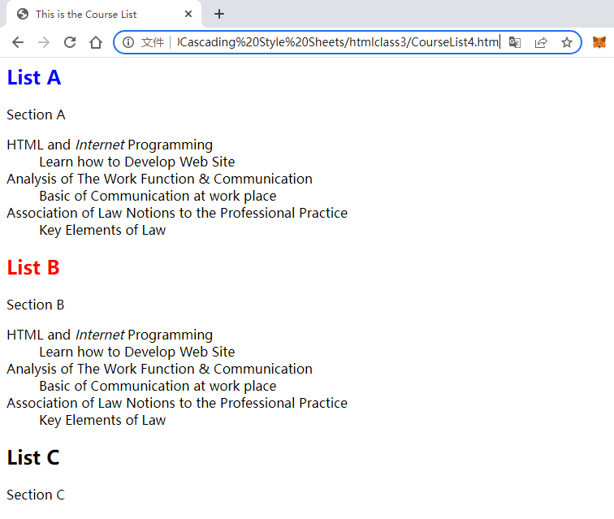

3. Working with Color in HTML and CSS

* Defining Text and Background Colors: You can apply a style to a specific element marked

courselist5.htm

1. **<html>**
2. **<head>**
3. **<title>**This is the Course List**</title>**
4. **<style** type="text/css"**>**
5. h1 {
6. background-color: green;
7. color: white;
8. }
9. h2, h3 {color: red;}
10. **</style>**
11. **</head>**
12. **<body>**
13. **<address>**
14. 821 Saint-Croix, Montreal, Quebec Canada H4L 3X9 **<b>**Tel: 514.744.7500**</b>**
15. **</address>**
16. **<h1>**Vanier College**</h1>**
17. **<h2>**Fall Semester 2022**</h2>**
18. **<h3>**Course List**</h3>**
19. **<dl>**
20. **<dt>**HTML and **<i>**Internet**</i>** Programming**</dt>**
21. **<dd>**Learn how to Develop Web Site**</dd>**
22. **<dt>**Analysis of The Work Function & Communication**</dt>**
23. **<dd>**Basic of Communication at work place**</dd>**
24. **<dt>**Association of Law Notions to the Professional Practice**</dt>**
25. **<dd>**Key Elements of Law**</dd>**
26. **</dl>**
27. **</body>**
28. **</html>**

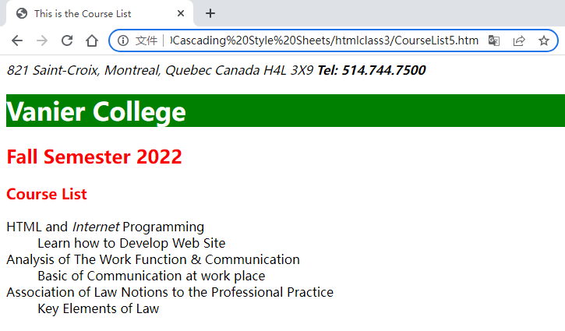

* **Working with Fonts, Text Styles, and Font Size:** You can specify a font and change the font size.

**courselist6.htm**

1. **<html>**
2. **<head>**
3. **<title>**This is the Course List**</title>**
4. **<link** rel="stylesheet" href="format6.css"**>**
5. **</head>**
6. **<body>**
7. **<address>**
8. 821 Saint-Croix, Montreal, Quebec Canada H4L 3X9 **<b>**Tel: 514.744.7500**</b>**
9. **</address>**
10. **<h1>**Vanier College**</h1>**
11. **<h2>**Fall Semester 2022**</h2>**
12. **<h3>**Course List**</h3>**
13. **<dl>**
14. **<dt>**HTML and **<i>**Internet**</i>** Programming**</dt>**
15. **<dd>**Learn how to Develop Web Site**</dd>**
16. **<dt>**Analysis of The Work Function & Communication**</dt>**
17. **<dd>**Basic of Communication at work place**</dd>**
18. **<dt>**Association of Law Notions to the Professional Practice**</dt>**
19. **<dd>**Key Elements of Law**</dd>**
20. **</dl>**
21. **</body>**
22. **</html>**

**format6.css**

1. body {**background-color**: white; **font-family**: Arial, Helvetica, sans-serif;}
2. h1 {**color**: white; **background-color**: rgb(0, 154, 0);}
3. h2, h3 {**color**: red;}
4. address {**text-align**: center; **color**: blue;  **font-size**: 2em;}

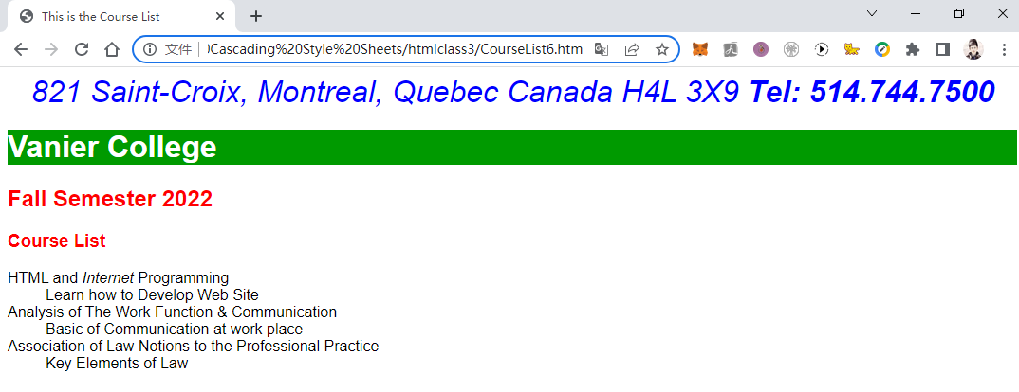

* Controlling Spacing and Indentation: You can specify the amount space between characters and the amount space between the words, and you can specify the text indent.

courselist7.htm

1. **<html>**
2. **<head>**
3. **<title>**This is the Course List**</title>**
4. **<link** rel="stylesheet" href="format7.css"**>**
5. **</head>**
6. **<body>**
7. **<address>**
8. 821 Saint-Croix, Montreal, Quebec Canada H4L 3X9 **<b>**Tel: 514.744.7500**</b>**
9. **</address>**
10. **<h1>**Vanier College**</h1>**
11. **<h2>**Fall Semester 2022**</h2>**
12. **<h3>**Course List**</h3>**
13. **<dl>**
14. **<dt>**HTML and **<i>**Internet**</i>** Programming**</dt>**
15. **<dd>**Learn how to Develop Web Site**</dd>**
16. **<dt>**Analysis of The Work Function & Communication**</dt>**
17. **<dd>**Basic of Communication at work place**</dd>**
18. **<dt>**Association of Law Notions to the Professional Practice**</dt>**
19. **<dd>**Key Elements of Law**</dd>**
20. **</dl>**
21. **<p>**
22. HTML documents have htm or html as an extenion such as student.htm or student.html.
23. We gonna use Notepad++ to edit HTML documents.
24. What are computerization and personal assets that should
25. be acquired by a student to succeed and perform in her study?
26. Do you have any specific expectations about your long term evolution?
27. **</p>**
28. **</body>**
29. **</html>**

format7.css

1. body {**background-color**: white; **font-family**: Arial, Helvetica, sans-serif;}
2. h1 {**color**: white; **background-color**: rgb(0, 154, 0);
3. **letter-spacing**: 0.3em; **word-spacing**: 0.8em;}
4. h2, h3 {**color**: red; **word-spacing**: 0.8em;}
5. address {**text-align**: center; **color**: blue;  **font-size**: 2em;}
6. p {**font-size**: 1em;}

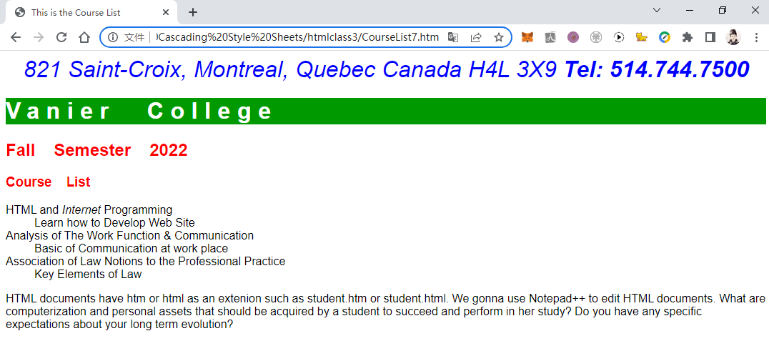

* Applying Font Features:

You can specify the font style to particular type such as normal, italic, oblique.

**courselist8.htm**

1. **<html>**
2. **<head>**
3. **<title>**This is the Course List**</title>**
4. **<link** rel="stylesheet" href="format8.css"**>**
5. **</head>**
6. **<body>**
7. **<address>**
8. 821 Saint-Croix, Montreal, Quebec Canada H4L 3X9 **<b>**Tel: 514.744.7500**</b>**
9. **</address>**
10. **<h1>**Vanier College**</h1>**
11. **<h2>**Fall Semester 2022**</h2>**
12. **<h3>**Course List**</h3>**
13. **<dl>**
14. **<dt>**HTML and **<i>**Internet**</i>** Programming**</dt>**
15. **<dd>**Learn how to Develop Web Site**</dd>**
16. **<dt>**Analysis of The Work Function & Communication**</dt>**
17. **<dd>**Basic of Communication at work place**</dd>**
18. **<dt>**Association of Law Notions to the Professional Practice**</dt>**
19. **<dd>**Key Elements of Law**</dd>**
20. **</dl>**
21. **<p>**
22. HTML documents have htm or html as an extenion such as student.htm or student.html.
23. We gonna use Notepad++ to edit HTML documents.
24. What are computerization and personal assets that should
25. be acquired by a student to succeed and perform in her study?
26. Do you have any specific expectations about your long term evolution?
27. **</p>**
28. **</body>**
29. **</html>**

**format8.css**

1. body {**background-color**: white; **font-family**: Arial, Helvetica, sans-serif;}
2. h1 {**color**: white; **background-color**: rgb(0, 154, 0);
3. **letter-spacing**: 0.3em; **word-spacing**: 0.8em;}
4. h2, h3 {**color**: red; **word-spacing**: 0.8em;}
5. address {**text-align**: center; **color**: blue;  **font-size**: 2em; **font-style**: normal;
6. **font-weight**: bolder; **text-decoration**: overline; **text-transform**: uppercase;}
7. p {**font-size**: 1em;}

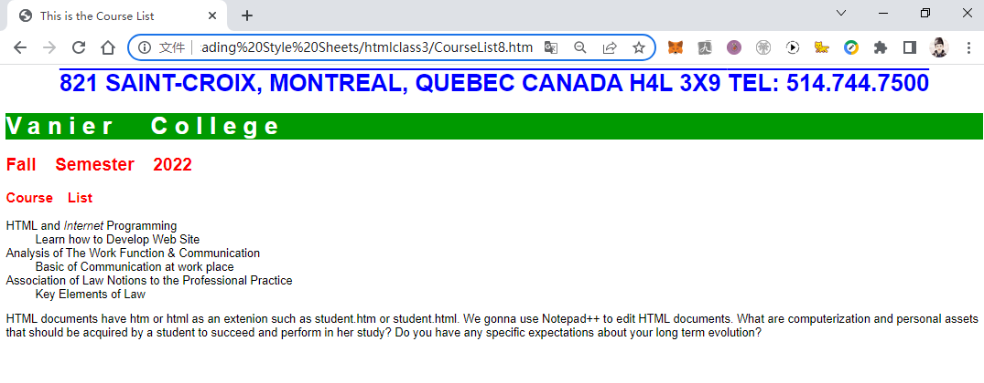

4. Working with Images

You can change the background of any element from its plain white color to the uploaded image  
using background-image attribute

**courselist9.htm**

1. **<html>**
2. **<head>**
3. **<title>**This is the Course List**</title>**
4. **<link** rel="stylesheet" href="format9.css"**>**
5. **</head>**
6. **<body** background="./Nwlogo.jpg"**>**
7. **<address>**
8. 821 Saint-Croix, Montreal, Quebec Canada H4L 3X9 **<b>**Tel: 514.744.7500**</b>**
9. **</address>**
10. **<h1>**Vanier College**</h1>**
11. **<h2>**Fall Semester 2022**</h2>**
12. **<h3>**Course List**</h3>**
13. **<dl>**
14. **<dt>**HTML and **<i>**Internet**</i>** Programming**</dt>**
15. **<dd>**Learn how to Develop Web Site**</dd>**
16. **<dt>**Analysis of The Work Function & Communication**</dt>**
17. **<dd>**Basic of Communication at work place**</dd>**
18. **<dt>**Association of Law Notions to the Professional Practice**</dt>**
19. **<dd>**Key Elements of Law**</dd>**
20. **</dl>**
21. **<p>**
22. HTML documents have htm or html as an extenion such as student.htm or student.html.
23. We gonna use Notepad++ to edit HTML documents.
24. What are computerization and personal assets that should
25. be acquired by a student to succeed and perform in her study?
26. Do you have any specific expectations about your long term evolution?
27. **</p>**
28. **</body>**
29. **</html>**

**format9.css**

1. body {**background-color**: white; **font-family**: Arial, Helvetica, sans-serif;}
2. h1 {**color**: white; **background-color**: rgb(0, 154, 0);
3. **letter-spacing**: 0.3em; **word-spacing**: 0.8em;}
4. h2, h3 {**color**: red; **word-spacing**: 0.8em;}
5. address {**text-align**: center; **color**: blue;  **font-size**: 2em; **font-style**: normal;
6. **font-weight**: bolder; **text-decoration**: overline; **text-transform**: uppercase;}
7. p {**font-size**: 1em;}

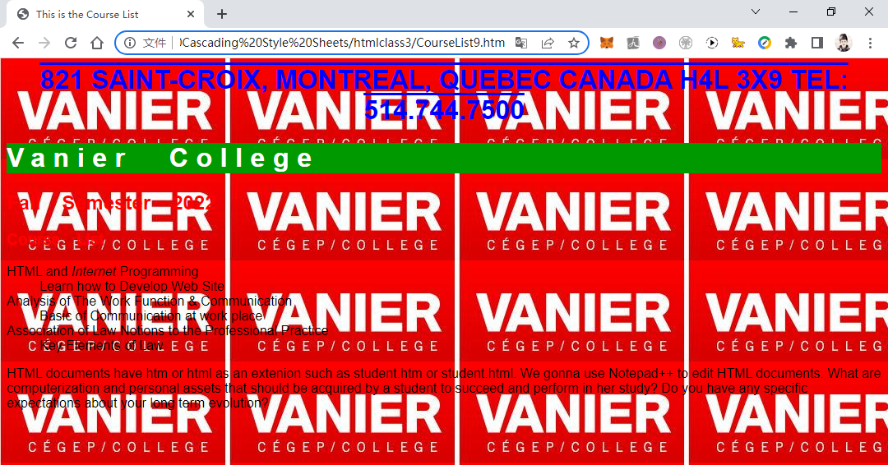

5. Floating an Element: an In-line image is floated when it is moved alongside  
**courselist10.htm**

1. **<html>**
2. **<head>**
3. **<title>**This is the Course List**</title>**
4. **<link** rel="stylesheet" href="format10.css" type="text/css"**>**
5. **</head>**
6. **<body>**
7. **<address>**
8. 821 Saint-Croix, Montreal, Quebec Canada H4L 3X9 **<b>**Tel: 514.744.7500**</b>**
9. **</address>**
10. **<h1>**Vanier College**</h1>**
11. **<h2>**Fall Semester 2022**</h2>**
12. **<h3>**Course List**</h3>**
13. **<img** src="./Nwlogo.jpg" alt="Vanier"**>**
14. **<dl>**
15. **<dt>**HTML and **<i>**Internet**</i>** Programming**</dt>**
16. **<dd>**Learn how to Develop Web Site**</dd>**
17. **<dt>**Analysis of The Work Function & Communication**</dt>**
18. **<dd>**Basic of Communication at work place**</dd>**
19. **<dt>**Association of Law Notions to the Professional Practice**</dt>**
20. **<dd>**Key Elements of Law**</dd>**
21. **</dl>**
22. **<p>**
23. HTML documents have htm or html as an extenion such as student.htm or student.html.
24. We gonna use Notepad++ to edit HTML documents.
25. What are computerization and personal assets that should
26. be acquired by a student to succeed and perform in her study?
27. Do you have any specific expectations about your long term evolution?
28. **</p>**
29. **</body>**
30. **</html>**

**format10.css**

1. body {**background-color**: white; **font-family**: Arial, Helvetica, sans-serif;}
2. h1 {**color**: white; **background-color**: rgb(0, 154, 0);
3. **letter-spacing**: 0.3em; **word-spacing**: 0.8em;}
4. h2, h3 {**color**: red; **word-spacing**: 0.8em;}
5. address {**text-align**: center; **color**: blue;  **font-size**: 2em; **font-style**: normal;
6. **font-weight**: bolder; **text-decoration**: overline; **text-transform**: uppercase;}
7. p {**font-size**: 1em;}
8. img {**float**: right;}

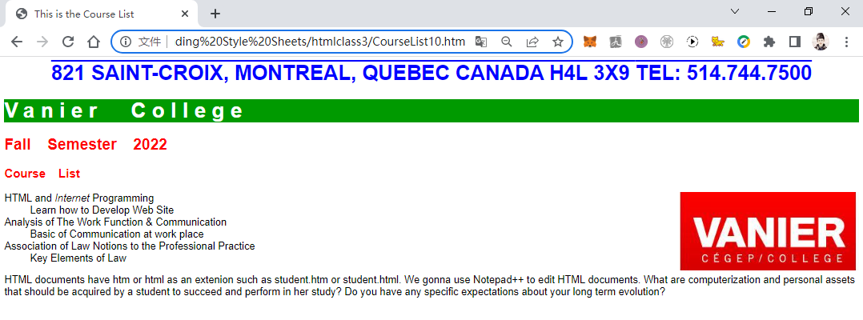

6. Working with the Box Model:

* Margin Styles: you can set the element margin:

**courselist11.htm**

1. **<html>**
2. **<head>**
3. **<title>**This is the Course List**</title>**
4. **<link** rel="stylesheet" href="format11.css" type="text/css"**>**
5. **</head>**
6. **<body>**
7. **<address>**
8. 821 Saint-Croix, Montreal, Quebec Canada H4L 3X9 **<b>**Tel: 514.744.7500**</b>**
9. **</address>**
10. **<h1>**Vanier College**</h1>**
11. **<h2>**Fall Semester 2022**</h2>**
12. **<h3>**Course List**</h3>**
13. **<img** src="./Nwlogo.jpg" alt="Vanier" style="float: right;"**>**
14. **<dl>**
15. **<dt>**HTML and **<i>**Internet**</i>** Programming**</dt>**
16. **<dd>**Learn how to Develop Web Site**</dd>**
17. **<dt>**Analysis of The Work Function & Communication**</dt>**
18. **<dd>**Basic of Communication at work place**</dd>**
19. **<dt>**Association of Law Notions to the Professional Practice**</dt>**
20. **<dd>**Key Elements of Law**</dd>**
21. **</dl>**
22. **<p>**
23. HTML documents have htm or html as an extenion such as student.htm or student.html.
24. We gonna use Notepad++ to edit HTML documents.
25. What are computerization and personal assets that should
26. be acquired by a student to succeed and perform in her study?
27. Do you have any specific expectations about your long term evolution?
28. **</p>**
29. **</body>**
30. **</html>**

**format11.css**

1. body {**background-color**: white; **font-family**: Arial, Helvetica, sans-serif;}
2. h1 {**color**: white; **background-color**: rgb(0, 154, 0);
3. **letter-spacing**: 0.3em; **word-spacing**: 0.8em;
4. **margin-top**: 10px; **margin-right**: 20px; **margin-bottom**: 10px; **margin-left**: 20px;}
5. h2, h3 {**color**: red; **word-spacing**: 0.8em;}
6. address {**text-align**: center; **color**: blue;  **font-size**: 2em; **font-style**: normal;
7. **font-weight**: bolder; **text-decoration**: overline; **text-transform**: uppercase;}
8. p {**font-size**: 1em;}
9. img {**float**: right;}

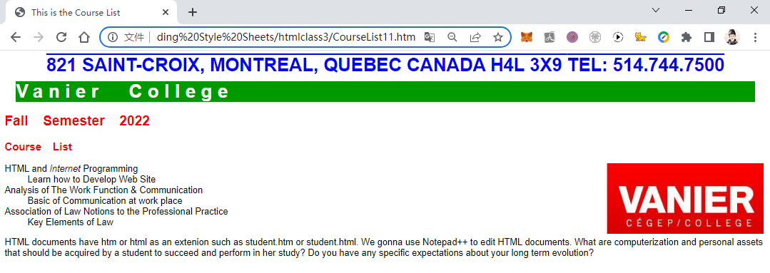

* **Padding Styles:** you can set the element padding:
* **Border Styles:** you can set the element border width, color, and design:
* **width Styles:** you can set the element border width, color, and design:

**courselist12.htm**

1. **<html>**
2. **<head>**
3. **<title>**This is the Course List**</title>**
4. **<link** rel="stylesheet" href="format12.css" type="text/css"**>**
5. **</head>**
6. **<body>**
7. **<address>**
8. 821 Saint-Croix, Montreal, Quebec Canada H4L 3X9 **<b>**Tel: 514.744.7500**</b>**
9. **</address>**
10. **<h1>**Vanier College**</h1>**
11. **<h2>**Fall Semester 2022**</h2>**
12. **<h3>**Course List**</h3>**
13. **<img** src="./Nwlogo.jpg" alt="Vanier" style="float: right;"**>**
14. **<dl>**
15. **<dt>**HTML and **<i>**Internet**</i>** Programming**</dt>**
16. **<dd>**Learn how to Develop Web Site**</dd>**
17. **<dt>**Analysis of The Work Function & Communication**</dt>**
18. **<dd>**Basic of Communication at work place**</dd>**
19. **<dt>**Association of Law Notions to the Professional Practice**</dt>**
20. **<dd>**Key Elements of Law**</dd>**
21. **</dl>**
22. **<p>**
23. HTML documents have htm or html as an extenion such as student.htm or student.html.
24. We gonna use Notepad++ to edit HTML documents.
25. What are computerization and personal assets that should
26. be acquired by a student to succeed and perform in her study?
27. Do you have any specific expectations about your long term evolution?
28. **</p>**
29. **</body>**
30. **</html>**

**format12.css**

1. body {**background-color**: white; **font-family**: Arial, Helvetica, sans-serif;}
2. h1 {**color**: white; **background-color**: rgb(0, 154, 0);
3. **letter-spacing**: 0.3em; **word-spacing**: 0.8em;
4. **margin-top**: 10px; **margin-right**: 20px; **margin-bottom**: 10px; **margin-left**: 20px;
5. **padding**: 10 20 10 20;}
6. h2, h3 {**color**: red; **word-spacing**: 0.8em;}
7. address {**text-align**: center; **color**: blue;
8. **border-bottom-width**: 4px; **border-bottom-color**: red; **border-bottom-style**: double;}
9. p {**font-size**: 1em; **padding**: 20 20 20 20; **width**: 450px;
10. **border-style**: solid; **border-width**: 10px; **border-color**: green;}
11. img {**float**: right;}

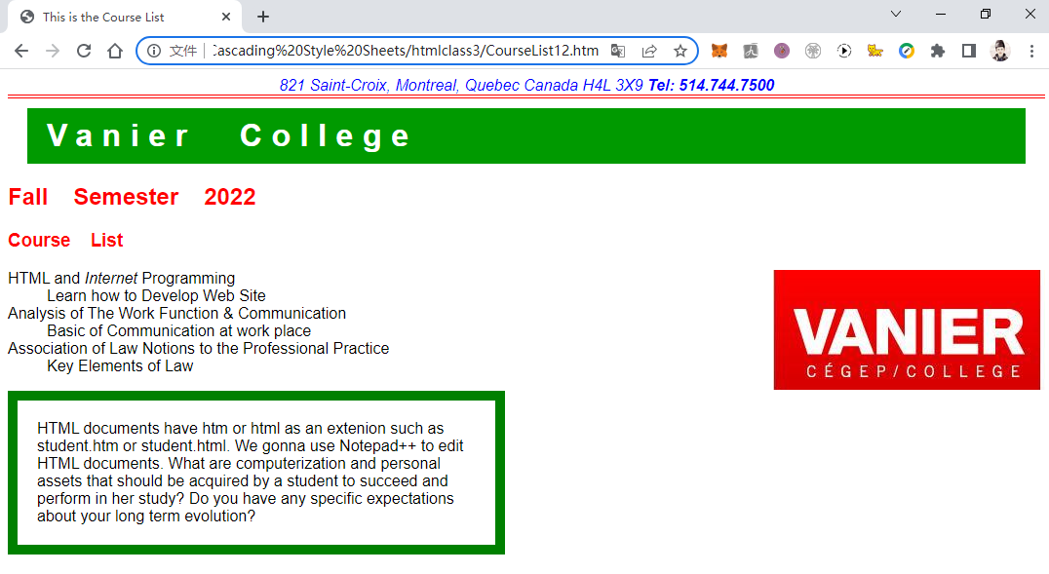

7. Controlling Page Layout with div Containers:

**courselist13.htm**

1. **<html>**
2. **<head>**
3. **<title>**This is the Course List**</title>**
4. **<link** rel="stylesheet" href="format13.css" type="text/css"**>**
5. **</head>**
6. **<body>**
7. **<div** class="container"**>**
8. **<address>**
9. 821 Saint-Croix, Montreal, Quebec Canada H4L 3X9 **<b>**Tel: 514.744.7500**</b>**
10. **</address>**
11. **<h1>**Vanier College**</h1>**
12. **<h2>**Fall Semester 2022**</h2>**
13. **<h3>**Course List**</h3>**
14. **<img** src="./Nwlogo.jpg" alt="Vanier" style="float: right;"**>**
15. **<dl>**
16. **<dt>**HTML and **<i>**Internet**</i>** Programming**</dt>**
17. **<dd>**Learn how to Develop Web Site**</dd>**
18. **<dt>**Analysis of The Work Function & Communication**</dt>**
19. **<dd>**Basic of Communication at work place**</dd>**
20. **<dt>**Association of Law Notions to the Professional Practice**</dt>**
21. **<dd>**Key Elements of Law**</dd>**
22. **</dl>**
23. **<p>**
24. HTML documents have htm or html as an extenion such as student.htm or student.html.
25. We gonna use Notepad++ to edit HTML documents.
26. What are computerization and personal assets that should
27. be acquired by a student to succeed and perform in her study?
28. Do you have any specific expectations about your long term evolution?
29. **</p>**
30. **</div>**
31. **</body>**
32. **</html>**

**format13.css**

1. body {**background-color**: white; **font-family**: Arial, Helvetica, sans-serif;}
2. h1 {**color**: white; **background-color**: rgb(0, 154, 0);
3. **letter-spacing**: 0.3em; **word-spacing**: 0.8em;
4. **margin-top**: 10px; **margin-right**: 20px; **margin-bottom**: 10px; **margin-left**: 20px;
5. **padding**: 10 20 10 20;}
6. h2, h3 {**color**: red; **word-spacing**: 0.8em;}
7. address {**text-align**: center; **color**: blue;
8. **border-bottom-width**: 4px; **border-bottom-color**: red; **border-bottom-style**: double;}
9. p {**font-size**: 1em; **padding**: 20 20 20 20; **width**: 450px;
10. **border-style**: solid; **border-width**: 10px; **border-color**: green;}
11. img {**float**: right;}
12. .container {**width**: 700px;}

